**How many… are there?**

1. How many backpacks are there?

There **are** _________________________ backpack**s**.



1. How many pencils are there?

There **is** _________________________ pencil.

1. How many books are there?

There are _________________________ books.



1. How many erasers are there?

There is _____________________ ______________________.



1. How many boys are there?

There __________ ___________________ _________________.

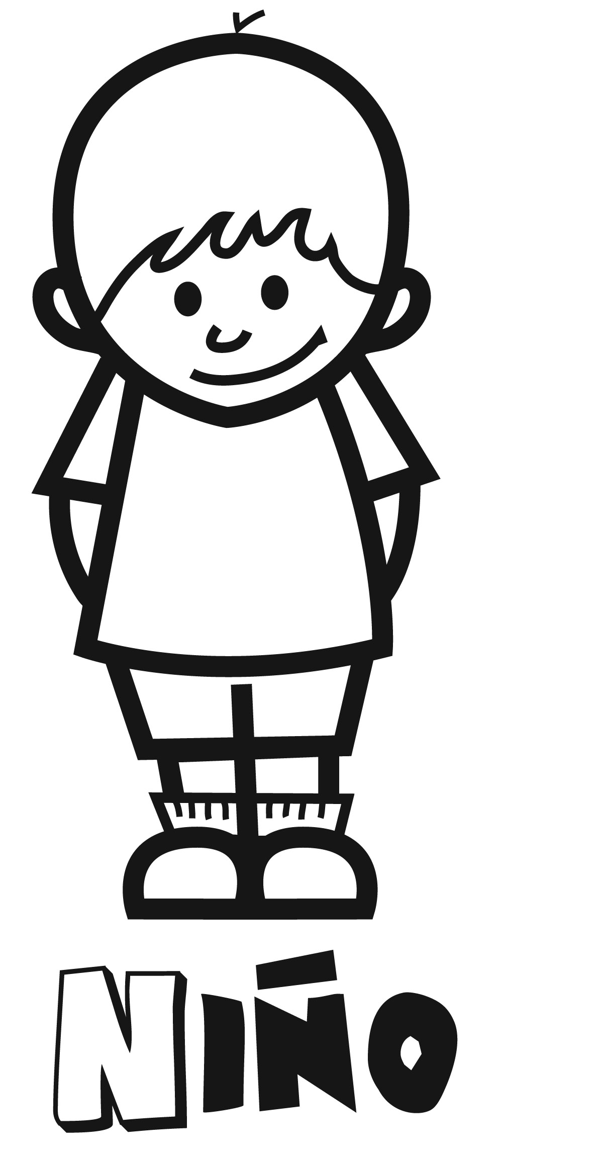           

1. How many notebooks are there?

There __________ ________________ _________________



1. How many circles are there?

There __________ ________________ _________________

                  

1. How many computers are there?

There __________ ________________ _________________



1. How many rectangles are there?

There __________ ________________ _________________

 

1. How many pencil cases are there?

There __________ ________________ _________________

[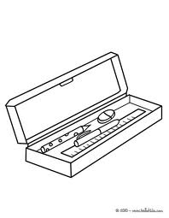](http://www.google.com.pe/imgres?q=PENCIL+CASE+TO+COLOR&hl=es&biw=1088&bih=446&tbm=isch&tbnid=WyS4OQpCMmPaPM:&imgrefurl=http://www.hellokids.com/c_22680/coloring-page/school-coloring-pages/school-supplies-coloring-page/a-pencil-case-coloring-page&docid=U-ECDpxL7XIh1M&imgurl=http://images.hellokids.com/_uploads/_tiny_galerie/20100834/a-pencil-case-with-rubber-pens-pencil-ruler-01-723_3z6.jpg&w=364&h=470&ei=dGMHT8GTGIHtggeWkIiXDw&zoom=1)

1. How many students are there in your classroom?

There __________ ________________ _________________