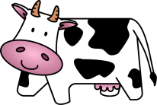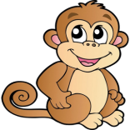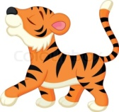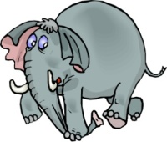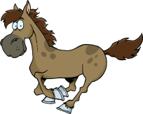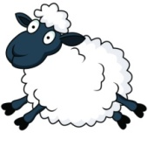**How many……?**

There are four elephants.

**1.** How many elephants are there? **2.** How many sheep are there?

_________________ _________________

**3.** How many giraffes are there? **4.** How many monkeys are there?

_________________ _________________

**5.** How many tigers are there? **6.** How many pigs are there?

_________________ _________________

**7.** How many cows are there? **8.** How many horses are there?

_________________ _________________

**9.** How many alligators are there? **10.** How many dogs are there?

_________________ _________________