Shopping: What can you buy in these shops?
B: Use the products in the list below to make about what you can buy in each shop:
florist shoe shop toy shop greengrocer butcher sport shop card shop newsagent’s fishmonger charity shop furniture shop phone shop chemist clothes shop jeweller’s electrical shop

Example: beds, chairs, sofas: You can buy beds & sofas from a furniture shop.
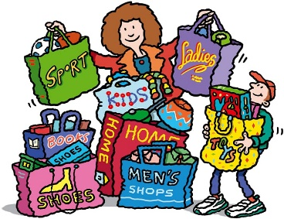
1. necklaces, rings: ________________________________________
2. beef steaks: ___________________________________________
3. fish, crab: ____________________________________________
4.envelops, stamps: ________________________________________
5. a bouquet of flowers: ____________________________________
6. bananas, apples, tomatoes: ___________________________________________________
7. balls, tracksuit, trainers: ____________________________________________________
8. cookies, bread, pies: ________________________________________________________
9. shampoo, medicine, nappies: __________________________________________________
10. shoes, sandals, boots: ______________________________________________________
11.SIM cards, phone batteries: _________________________________________________
12. cigarettes, newspaper, sweets: ______________________________________________
13. wrapping paper, cards: ______________________________________________________
14. dresses, shirts, trousers: ____________________________________________________
15. dolls, games, puzzles: ___________________________________________________
16. fridge, washing machine: ________________________________________________
17. second hand clothes, furniture: ___________________________________________

